Q1) Calculate Skewness, Kurtosis & draw inferences on the following data

a. Cars speed and distance

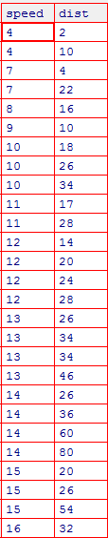

b. Top Speed (SP) and Weight (WT)

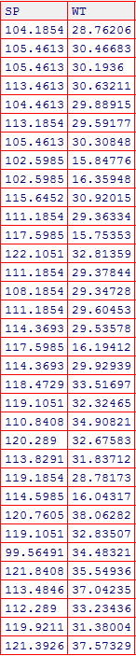

Q2) Draw inferences about the following boxplot & histogram





**Q3)** Suppose we want to estimate the average weight of an adult male in Mexico. We draw a random sample of 2,000 men from a population of 3,000,000 men and weigh them. We find that the average person in our sample weighs 200 pounds, and the standard deviation of the sample is 30 pounds. Calculate 94%,98%,96% confidence interval?

**Q4)** Below are the scores obtained by a student in tests

**34,36,36,38,38,39,39,40,40,41,41,41,41,42,42,45,49,56**

1. Find mean, median, variance, standard deviation.
2. What can we say about the student marks?

Q5) What is the nature of skewness when mean, median of data are equal?

Q6) What is the nature of skewness when mean > median?

Q7) What is the nature of skewness when median > mean?

Q8) What does positive kurtosis value indicates for a data?

Q9) What does negative kurtosis value indicates for a data?

Q10) Answer the below questions using the below boxplot visualization.



What can we say about the distribution of the data?

What is nature of skewness of the data?

What will be the IQR of the data (approximately)?

Q11) Comment on the below Boxplot visualizations?



Draw an Inference from the distribution of data for Boxplot 1 with respect Boxplot 2.

Q12)



Answer the following three questions based on the boxplot above.

1. What is inter-quartile range of this dataset? (please approximate the numbers) In one line, explain what this value implies.
2. What can we say about the skewness of this dataset?
3. If it was found that the data point with the value 25 is actually 2.5, how would the new boxplot be affected?

Q13)



Answer the following three questions based on the histogram above.

1. Where would the mode of this dataset lie?
2. Comment on the skewness of the dataset.
3. Suppose that the above histogram and the boxplot in question 2 are plotted for the same dataset. Explain how these graphs complement each other in providing information about any dataset.